High Level Design (HLD) Investment Analytics

Revision Number: 1.2

Last date of revision: 3/05/2023

Shreyas Patil

# Document Version Control

|  |  |  |  |
| --- | --- | --- | --- |
| **Date Issued** | **Version** | **Description** | **Author** |
| **1st May 2023** | 1.0 | Abstract, Introduction and general description | Shreyas Patil |
| **2nd May 2023** | 1.1 | Design detail, KPIs, and deployment | Shreyas Patil |
| **3rd May 2023** | 1.2 | Final Version of Complete HLD | Shreyas Patil |

**Contents**

Document Version Control 2

Abstract 3

1. Introduction 5
   1. Why this High-Level Design Document? 5
   2. Scope 5
2. General Description 6
   1. Product Perspective & Problem Statement 6
   2. Tools used 6
3. Design Details 7
   1. Functional Architecture 7
   2. Optimization 8
4. KPIs 9
   1. KPIs (Key Performance Indicators) 9
5. Deployment 9

# Abstract

This analysis examines various aspects of foreign direct investment (FDI) in India, including the highest and lowest valued sectors in the latest year, overall FDI trends and growth/decline in individual sectors over the past years. It also groups sectors for comparison, identifies the top five sectors in terms of FDI and reports on the sectors that reported the highest growth and decline in FDI over the past five years. In addition, this analysis identifies the sectors that have the most variation in FDIs and the proportion of each sector in the total FDI. Finally, it considers the presence of any specific clusters in the data and makes a forecast for FDI in the next year.

# Introduction

## Why this High-Level Design Document?

The purpose of this High-Level Design (HLD) Document is to add the necessary detail to the current project description to represent a suitable model for coding. This document is also intended to help detect contradictions prior to coding, and can be used as a reference manualfor how the modules interact at a high level.

The HLD will:

* + - Present all of the design aspects and define them in detail
    - Describe the user interface being implemented
    - Describe the hardware and software interfaces
    - Describe the performance requirements
    - Include design features and the architecture of the project
    - List and describe the non-functional attributes like:
      * Security
      * Reliability
      * Maintainability
      * Portability
      * Reusability
      * Application compatibility
      * Resource utilization
      * Serviceability

## Scope

The HLD documentation presents the structure of the system, such as the database architecture, application architecture (layers), application flow (Navigation), and technology architecture. The HLD uses non-technical to mildly-technical terms which should be understandable to the administrators of the system.

# General Description

## Product Perspective & Problem Statement

Product perspective is focused on understanding and evaluating the trends and patterns in foreign direct investment India. The analysis considers various sectors and their FDI growth or decline over the past five years, as well as the proportion of each sector in the total FDI. The aim of this product perspective is to provide insights into the performance of different sectors and identify any patterns or clusters in FDI that may be relevant for future investment decisions. Ultimately, this analysis provides a product perspective that can inform business strategies and guide investment decisions for companies operating in India.

## Tools used

Business Intelligence tools and libraries works such as Numpy, Pandas, Excel, Tableau, are used to build the whole framework.





# Design Details

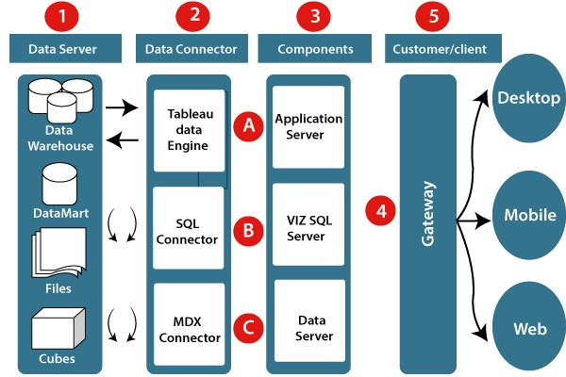

## Functional Architecture

Tableau Architecture

**How does Tableau Work?**

The major work of Tableau software is to connect and extract the data stored in various places. It can pull data from any platform. Tableau can extract data from any database, be it [Excel](https://intellipaat.com/blog/another-collaborator-for-data-analytics-those-excel-sheets/), PDF, Oracle, or even [Amazon Web Services](https://intellipaat.com/blog/tutorial/amazon-web-services-aws-tutorial/).

Once Tableau is launched, ready data connectors are available which allow you to connect to any database.

The data extracted can be connected live to the Tableau data engine, Tableau Desktop. This is where a [Data Analyst or a Data Engineer](https://intellipaat.com/blog/data-scientist-vs-data-analyst/) works with the data that was pulled up and develop visualization. The created dashboards are shared with users in the form of static files. The users receiving dashboards view the files using Tableau Reader.

The data extracted from Tableau Desktop can be published to [Tableau Server](https://intellipaat.com/blog/what-is-tableau-server/), which is an enterprise platform where collaboration, distribution, governance, security model, and automation features are supported. Using Tableau Server, end users can access the files from all locations, be it a desktop or a mobile phone.

### Optimization

### Your data strategy drives performance

* + - Minimize the number of fields
    - Minimize the number of records
    - Optimize extracts to speed up future queries by materializing calculations, removingcolumns and the use of accelerated views

### Reduce the marks (data points) in your view

* + - Practice guided analytics. There’s no need to fit everything you plan to show in a single view. Compile related views and connect them with action filters to travel from overviewto highly-granular views at the speed of thought.
    - Remove unneeded dimensions from the detail shelf.
    - Explore. Try displaying your data in different types of views.

### Limit your filters by number and type

* + - Reduce the number of filters in use. Excessive filters on a view will create a more complex query, which takes longer to return results. Double-check your filters and remove any that aren’t necessary.
    - Use an include filter. Exclude filters load the entire domain of a dimension, while include filters do not. An include filter runs much faster than an exclude filter, especiallyfor dimensions with many members.
    - [Use a continuous date filter](http://onlinehelp.tableau.com/current/pro/online/mac/en-us/help.htm#filtering_add_dragfields_dates.html). Continuous date filters (relative and range-of- date filters) can take advantage of the indexing properties in your database and are faster than discrete date filters.
    - [Use Boolean or numeric filters](http://www.tableau.com/learn/tutorials/on-demand/logical-calculations). Computers process integers and Booleans (t/f) much faster than strings.
    - Use [parameters](http://onlinehelp.tableau.com/current/pro/online/en-us/help.htm#parameters.html) and [action filters](http://onlinehelp.tableau.com/current/pro/online/en-us/help.htm#actions.html). These reduce the query load (and work across datasources).

# KPIs

Dashboards will be implemented to display and indicate certain KPIs and relevant indicators for the investment.



As and when, the system starts to capture the historical/periodic data for a specific year, the dashboards will be included to display charts over time with progress on various indicators orfactors

## KPIs (Key Performance Indicators)

Key indicators displaying a summary of the Investment Analysis and its relationship with different metrics

1. Total FDI growth rate: This KPI measures the overall growth rate of FDI in India over the past five years, which provides an overview of the country's attractiveness to foreign investors.
2. Sector-wise FDI growth rate: This KPI measures the growth rate of FDI in each sector over the past five years, which helps identify the sectors that have experienced high or low FDI growth.
3. Proportion of FDI by sector: This KPI measures the proportion of FDI invested in each sector, which helps identify the sectors that are attracting the most investment.
4. FDI inflow/outflow ratio: This KPI measures the ratio of FDI inflow to outflow, which helps identify the net amount of FDI coming into or going out of the country.
5. FDI concentration index: This KPI measures the level of concentration of FDI in specific sectors, which helps identify the sectors that are dominating the FDI inflow.
6. FDI cluster analysis: This KPI involves using clustering algorithms to group sectors with similar FDI patterns, which helps identify potential investment opportunities in related sectors.

# Deployment

Tableau prioritizes choice in flexibility to fit, rather than dictate, your enterprise architecture. Tableau Server and Tableau Online leverage your existing technology investments and integrate into your IT infrastructure to provide a self-service, modern analytics platform for your users. With on-premises, cloud, and hosted options, there is a version of Tableau to match your requirements.

The Dashboard is published on Tableau and an auto-refresh mode has been set so that the dashboard keeps on updating as the real-time data loads into the log file. The Dashboard showcases the multiple insights that have been drawn from the log files as follows:

**Sectors which got maximum FDI:**

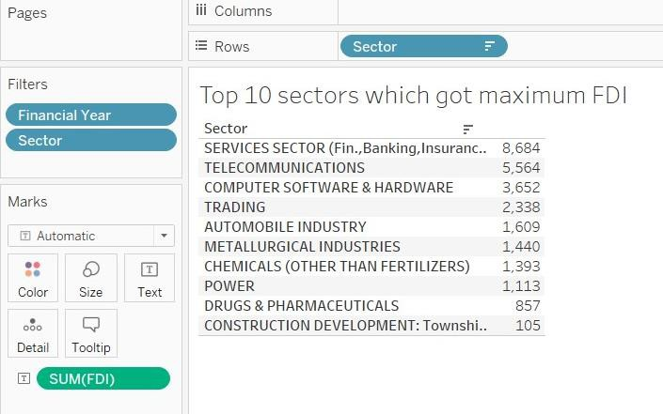

**Sectors which got minimum FDI**

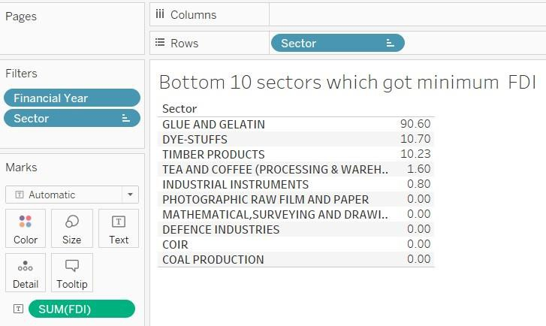

**FDI over the years**

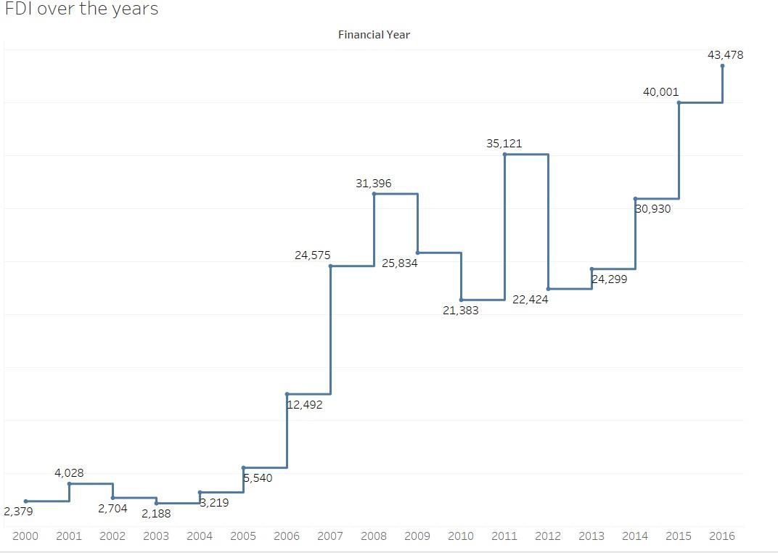

**High growth FDI sectors**

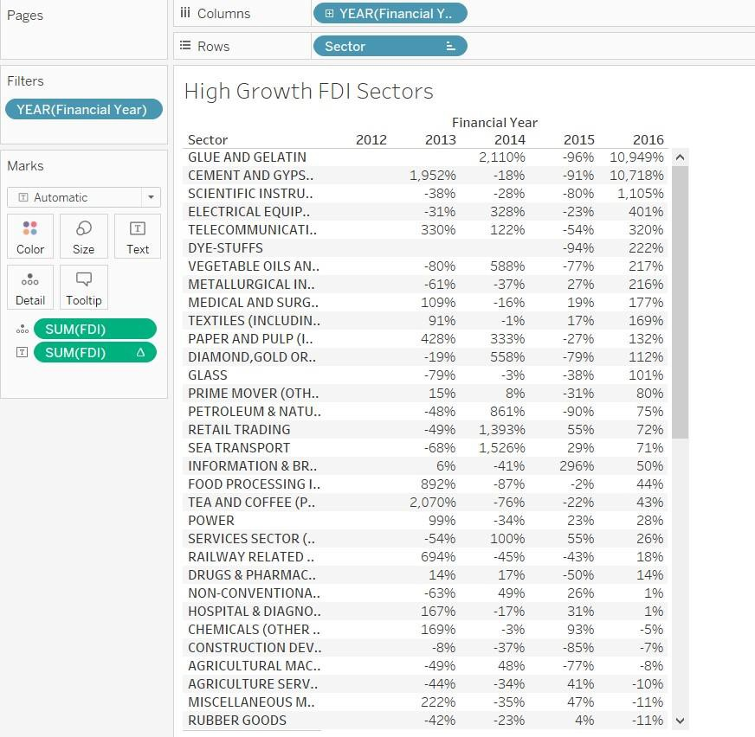

**Low growth FDI sectors**

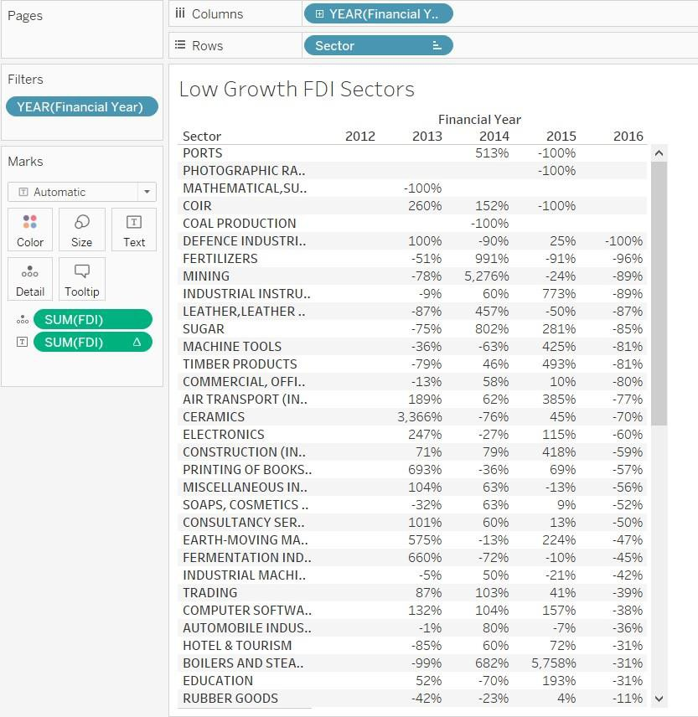

**Proportion of FDI**

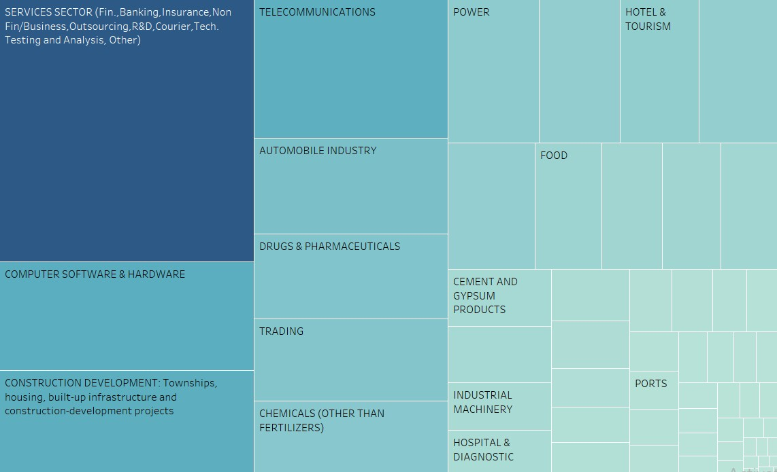

**Specific Clusters**

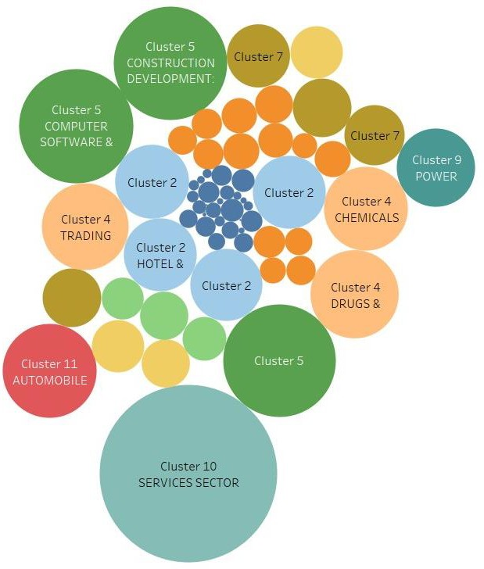

**Line Chart**

